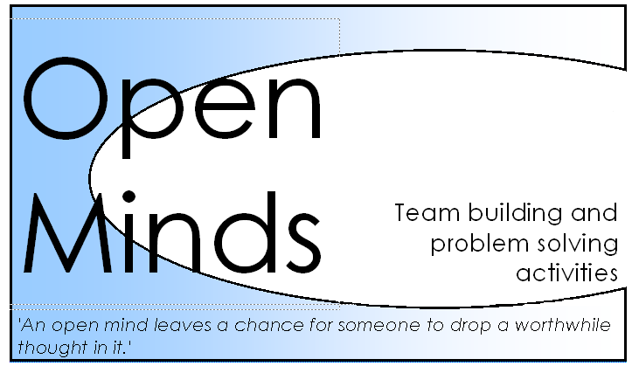

Open Minds follows the National Curriculum when providing activities in schools and colleges and offers opportunity for assessment. In discussion with staff, we focus on objectives and specific aims for your group and ensure its relevance to the National Curriculum. Our activities can be utilised to cover various aspects documented below.

Early Years and Foundation Stage

1.1 Child development
A skilful communicator
A competent learner
Effective practice
Challenges and dilemmas
Reflecting on practice
1.2 Inclusive Practice
Equality and diversity
Early support
Effective practice
Challenges and dilemmas
Reflecting on practice
1.3 Keeping Safe
'Keeping safe' is one of the commitments to the EYFS principle of 'A unique child'. This includes information about keeping babies and children safe and protected - babies and children are vulnerable as they have little sense of danger. Practitioners can help children discover boundaries and learn to make choices.
Discovering boundaries
Making choices
Effective practice
Challenges and dilemmas
Reflecting on practice
1.4 Health and Well-being
Physical well-being
Emotional well-being
Effective practice
Challenges and dilemmas
Reflecting on practice
2.1 Respecting Each Other
'Respecting each other' is one of the commitments to the EYFS principle of ' Positive relationships'. This includes understanding and recognising feelings, supporting children in developing friendships, setting an example through open and friendly professional relationships and developing a friendly relationship with parents.
Friendships
Professional relationships
Effective practice
Challenges and dilemmas
Reflecting on practice
2.2 Parents as Partners
‘Parents as partners’ is one of the commitments to the EYFS principle of ' Positive relationships'. This includes respecting diversity by valuing all families, good and welcoming communication by approachable staff, learning together with parents, reflecting children’s home language in the setting, involving fathers and male carers, and reflecting on practice in relation to parents and carers.
Communication
Learning together
Effective practice
Challenges and dilemmas
Reflecting on practice
2.3 Supporting Learning
Listening to children
Effective teaching
Effective practice
Challenges and dilemmas
Reflecting on practice
4.1 Play and Exploration
Practitioners need to ensure effective practice and reflection, overcoming time constraints and balancing creative learning with planning for the group.
Adult involvement
Contexts for learning
Effective practice
Challenges and dilemmas
Reflecting on practice
4.2 Active Learning
‘Active Learning’ is one of the commitments to the EYFS principle of ‘Learning and development’. This includes description of how active learners need mental and physical involvement, and social and emotional engagement.
Decision making
Personalised learning
Effective practice
Challenges and dilemmas
Reflecting on practice
4.3 Creativity and Critical Thinking
‘Creativity and critical thinking’ is one of the commitments to the EYFS principle of ‘Learning and development’. The explanation of the commitment includes description of learning through making connections, transforming understanding and sustaining shared thinking.
Transforming understanding
Sustained shared thinking
Effective practice
Challenges and dilemmas
Reflecting on practice

4.4 Areas of Learning and Development
'Areas of Learning and Development' is one of the commitments to the EYFS principle of 'Learning and development'. This includes the practice guidance for all six areas of Learning and Development: Personal, Social and Emotional Development; Communication, Language and Literacy; Problem Solving, Reasoning and Numeracy; Knowledge and Understanding of the World; Physical Development; and Creative Development.

Problem solving, reasoning and numeracy (PSRN) - PSRN is one of the areas of the EYFS principle of 'Learning and development'. It details how problem solving, reasoning and numeracy are core to a baby or child's development, split into the aspects of: Numbers as labels and for counting; Calculating; and Shape, space and measures.

Creative Development - Guidance on the provision of support for children's creativity: their curiosity, exploration and play. They must be provided with opportunities to explore and share their thoughts, creativity, ideas and feelings, for example, through a variety of art, music, movement, dance, imaginative and role-play activities, mathematics, and design and technology.

